

**School of Computing and Information Technology**

|  |  |  |  |  |  |  |  |  |  |
| --- | --- | --- | --- | --- | --- | --- | --- | --- | --- |
| **Course Code:** BTCS15F7800 | | | **Project work Synopsis** | | | | **Year: 2020-2021** | | |
| **Sem: 7th & 8th (i.e.) Phase-I & II** | | |
| **Project Group Members Details** | | | | | | | | | |
| **Group No: D16** | | **Group Name: D16 Group** | | | | | | | |
| **Sl. No** | **SRN** | **Full Name** | | **Sec** | **Mobile No.** | **Email_ID** | | | **Sign** |
| **1** | R17CS080 | Bindu Bhargava Reddy Chintam | | B | 9849936686  9880390845 | R17CS080@cit.reva.edu.in | | |  |
| **2** | R17CS229 | Maram Venkata Nagasai Teja | | D | 9515734938 | R17CS229@cit.reva.edu.in | | |  |
| **3** | R17CS210 | M Sumanth | | D | 9591637777 | R17CS210@cit.reva.edu.in | | |  |
| **4** | R17CS208 | Lokireddy Sai Siddhardha Reddy | | D | 7036762096 | R17CS208@cit.reva.edu.in | | |  |
| **Project Details** | | | | | | | | | |
| **Project Title:** | | **Cluster of Personality, Behavior and Emotion Detection using Deep Learning (GUI- Based)** | | | | | | | |
| **Guide Details:** | | **Name: Prof. Raghavendra Reddy**  **Designation: Assistant Professor** | | | | | | **Mobile No:**  **9731025201** | |
| **Place of Project Work:** | | **GUI, Deep Learning and Computer Vision Related** | | | | | | | |
| **External Guide:** | | **Name:**  **Designation:** | | | | | | **Mobile No:** | |
| **Remarks by Guide:** | | | | | | | | **Guide Signature**  **Date:** 16-08-2020 | |

***Abstract:***

*Cluster of Personality, Behavior and Emotion Detection is a new domain in Deep Learning and Computer Vision. In this work an existing object detector, R-CNN, is trained for face detection and performance results are reported by using the learned model. Differing from the existing work, it is aimed to train the deep detector with a small number of training examples and also to perform instance segmentation along with an object bounding box detection. Our research focuses on emotion, personality (Age and Gender) and behavior (Drowsy, mask and Social Distancing) detection using deep learning techniques and combined preprocessing activities presented using GUI. Our methodology includes three major stages in the data value chain, pre-processing, deep learning and post-processing. R-CNN provides higher detection rates with respect to the baseline detector, higher face detection accuracy for the small, medium and large-scale faces, respectively. The experimentation compares the performance of various deep learning techniques on the facial image data and confirms that our approach enhanced significantly the image quality using intensive pre-processing and deep-learning, improves accuracy in Emotion, Behavior and Personality Predictions respectively.*

1. **Introduction:**

Emotion is a mental state associated with the nervous system associated with feeling, perceptions, behavioral reactions, and a degree of gratification or displeasure. Emotion detection has great potential in video surveillance, monitoring infants, disabled and elderly people. Human facial expressions are natural and direct means to communicate the emotions and intentions, especially in non-verbal communications. With improved and advanced image detection and processing technologies, accurate emotion detection seems fairly achievable. In reality, images taken with different backgrounds, color settings and poses are challenging to the existing emotion detection algorithms. The performance of various facial emotion recognition techniques is compared based on the number of expressions recognized and the complexity of the algorithms. Six basic emotions are universally experienced in all human cultures. A smile on the human face reveals happiness, and the lips and eyes show a curved shape. In sadness, the face expresses looseness with rising skewed eyebrows and frown. The anger on the human face is expressed with squeezed eyebrows, slender and stretched eyelids. The disgust expressions are expressed with pull down eyebrows and creased nose while surprise is expressed with eye-widening and mouth gaping. With the development of image processing techniques, human face recognition techniques have been applied so broadly.

Meanwhile, the gender identification technique based on human faces images has become to be one of mode recognition research focuses. Gender identification of human face images means that computers process human face images, extracts the features of images, then identifies the gender by using classification.

Age and gender, two of the key facemask attributes, play a very initial role in social communications, making age and gender approximation from a single image an important task in intelligent applications, such as access control, human computer interaction, law application, marketing intelligence and visual observation, etc. Age recognition plays a major role in Police investigation and Intelligence department as it is helpful in finding the actual suspect on the basis of his age. They could get a filtered-out result of that person who has performed criminal act or any other activity.

Driver Drowsiness is one of the leading causes of motor vehicular accidents.

For these reasons, risk alert system for drivers using a detector which can determine drowsiness is highly recommended. The alert system can awaken the drowsy driver or hand over the control to autonomous vehicle. Various techniques have been implemented to measure driver drowsiness. The techniques can be broadly classified into 3 categories

1. Driving pattern of the vehicle
2. Psychophysiological characteristics of drivers
3. Computer Vision techniques for driver monitoring

The monitoring of conduct, exercises, or other evolving data, for the most part of individuals or spots to influence, overseeing, coordinating, or ensuring them is named as surveillance. The observation methodologies can fuse recognition from a detachment by strategies for electronic apparatus, for instance, closed circuit TV (CCTV) cameras, or catch of electronically transmitted information, for instance, Internet movement or phone calls, and it can consolidate essential, for the most part low-advancement procedures, for instance, human knowledge administrators and postal square endeavor [1-4]. Various affiliations and people are sending video perception structures at their zones with Closed Circuit TV (CCTV) cameras for better security. The acquired video data is significant to keep the risks beforehand the bad behavior truly happens. These chronicles furthermore transform into a not too bad legitimate verification to recognize offenders after the occasion of bad behavior.

1. **Literature Survey:**

In year 2020 paper “Design of a Deep Face Detector by Mask R-CNN” [1] was published by Ozan Cakiroglu, Caner Ozer & Bilge Gunsel, Mask RCNN, is trained for face detection and performance results are reported by using the learned model. Differing from the existing work, it is aimed to train the deep detector with a small number of training examples and also to perform instance segmentation along with an object bounding box detection.

In year 2020 paper “Monitoring Social Distancing for Covid-19 Using OpenCV and Deep Learning” [2] was published by Rucha Visal, Atharva Theurkar & Bhairavi Shukla, Recently, the outbreak of Coronavirus Disease (COVID-19) has spread rapidly across the world and thus social distancing has become one of mandatory preventive measures to avoid physical contact. This survey paper emphasizes on a surveillance method which uses Open-CV, Computer vision and Deep learning to keep a track on the pedestrians and avoid overcrowding.

In year 2019 paper “Age and Gender Prediction using Deep Convolutional Neural Networks” [3] was published by Insha Rafique, Awais Hamid & Sheraz Naseer proposed deep CNN to improve age and gender predication from significant results can be obtained and a significant improvement can be seen in various tasks such as face recognition.

In year 2019 paper “Facial Emotion Analysis using Deep Convolution Neural Network” [4] was published by Rajesh Kumar G A , Ravi Kant Kumar, Goutam Sanyal are providing better approach to predict human emotions (Frames by Frames) using deep Convolution Neural Network (CNN) and how emotion intensity changes on a face from low level to high level of emotion.

1. **Problem Definition:**

Current problem is with COVID-19 which affected all around the world. This held many families behind whereas vaccine is not yet discovered till date. Social Distancing and Face Mask is only the solution to prevent this pandemic situation in and around you and wide spreading. In order to monitor everyone in and around is extremely impossible. Similarly, most of the road accidents were recorded only due to negligence of driver’s drowsiness and distraction. Mob fights and riots are mostly damaging youth lifestyle. These suspicious Activities need to be prevented in order to protect youth and employees in an organization. Human facial expressions are natural and direct means to communicate the emotions and intentions, especially in non-verbal communications. Age and gender, two of the key facemask attributes, play a very initial role in social communications.

Desired solution in order to crisscross this we need a high- level Sophisticated Deep learning model to train and implement to monitor the above said problem states. Efficiency here matter a lot and performance is a major factor that plays a vital role in multitasking.

1. **Methodology:**

**Requirements:**

* Hardware:
* Webcam/GoProCam
* Laptop/Desktop
* Software:
* Python GUI - Tkinter

1. OpenCV
2. Keras
3. Matplotlib
4. SciPy
5. TensorFlow
6. Numpy

* Images
* Videos

**Approach:**

* Data Preprocessing – Removing Redundancy
* Regression – Simple Linear Regression
* Classification – K Neighbor
* Modelling - CNN Model – Convolution Neural Network
* Naïve Bayer’s Approach

**Algorithms:**

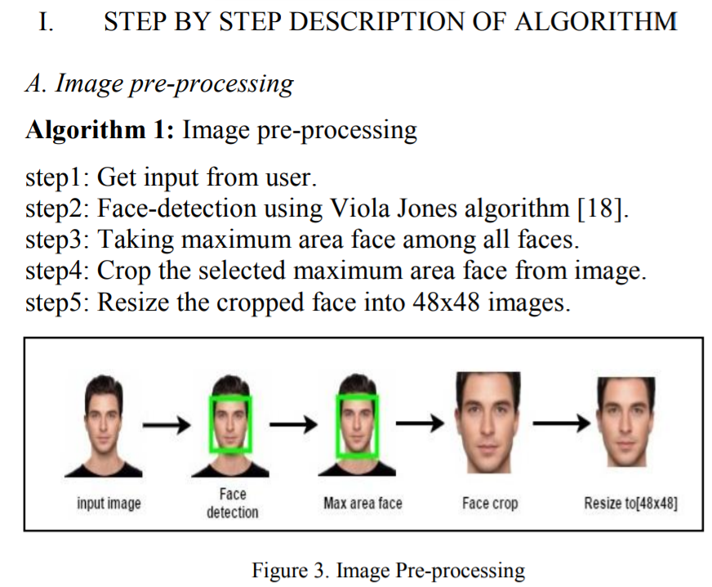

*B. Regression: Simple Linear Regression (To test the model)*

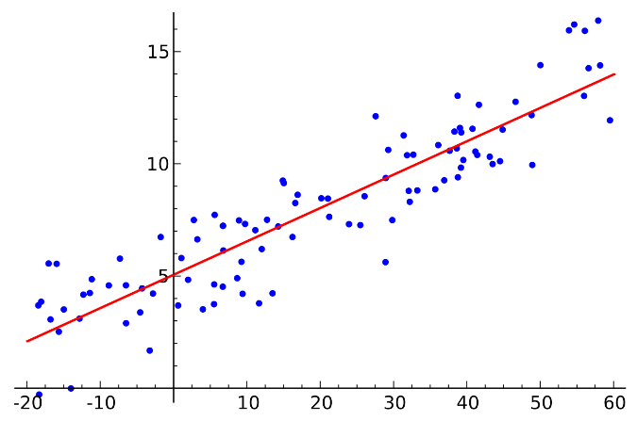

*C. Classifier – K Neighbor*

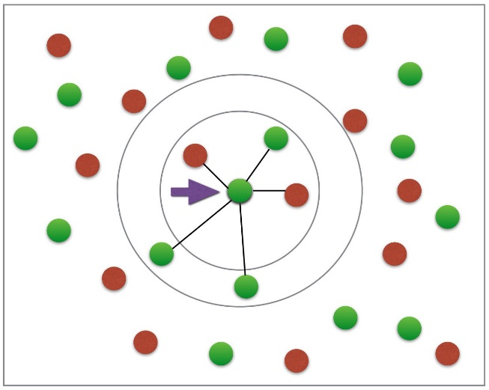

*D. CNN Model:*

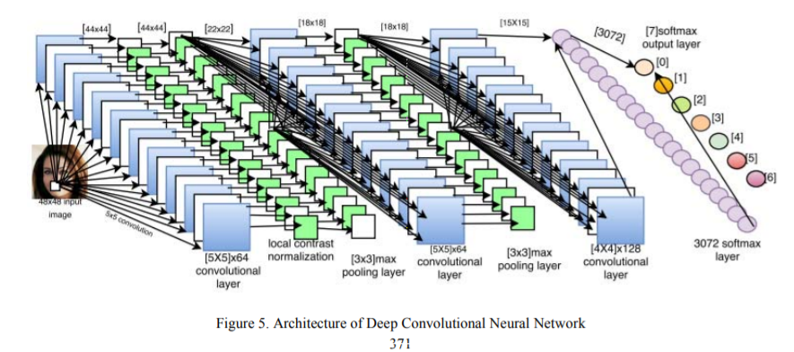

**Block Diagram for Age and Gender (Facial Emotion Detection) Classifier:**

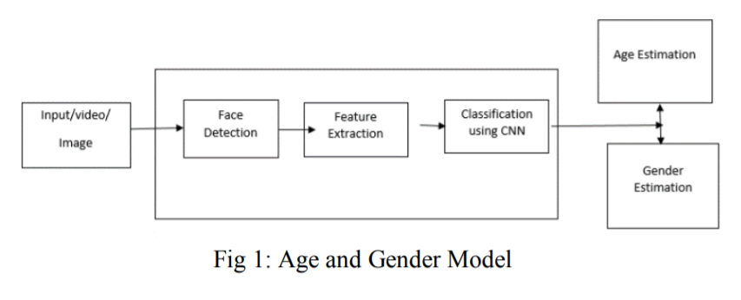

**Block Diagram for Face Mask, Social Distancing, Drowsiness & Suspicious Activity:**

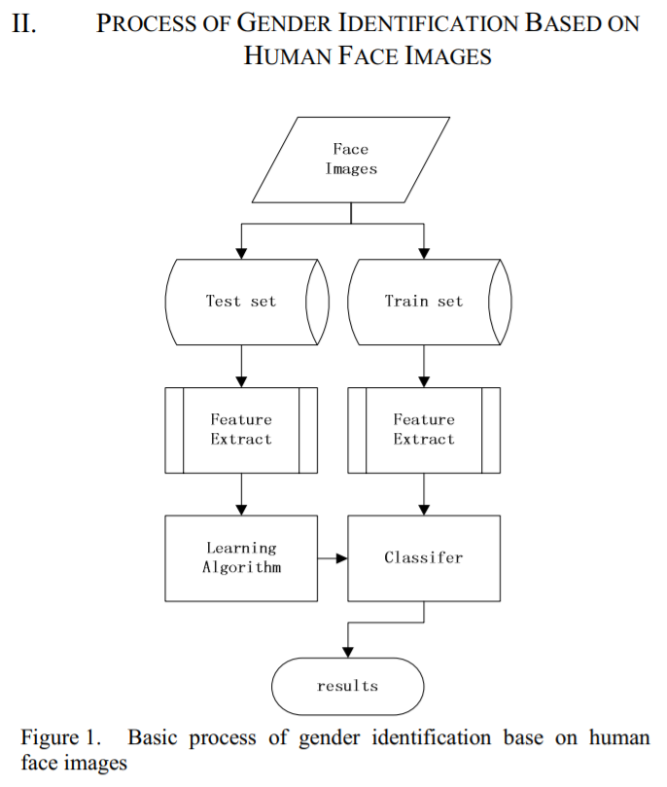

1. **Applications:**

* Emotion detection has great potential in video surveillance, monitoring infants, disabled and elderly people. Used to retain the facial feedback based on their expressions after and before visiting a Movie, Market, Park, Complex and Malls, etc.
* Age and gender recognition plays a major role in Police investigation and Intelligence department as it is helpful in finding the actual suspect on the basis of his age and gender. They could get a filtered-out result of that person who has performed criminal act or any other activity.
* The alert system can awaken the drowsy driver or hand over the control to autonomous vehicle.
* Suspicious activities detection identified using video surveillance to transform into a too bad legitimate verification to recognize offenders after the occasion of bad behavior.
* Social Distancing and Face Mask Monitoring is only the solution to prevent this pandemic situation in and around you and wide spreading.

1. **Expected Outcome and Result:**

**Output for Emotion detection:**

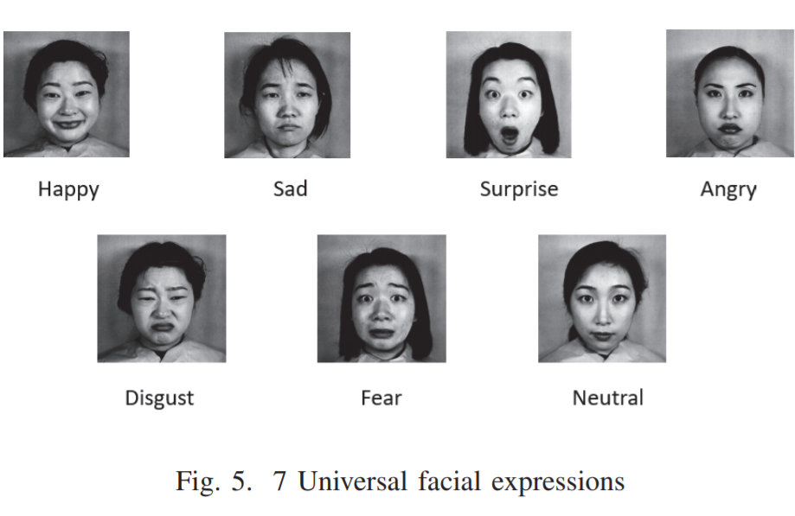

**Output for Face Mask and Social Distancing:**

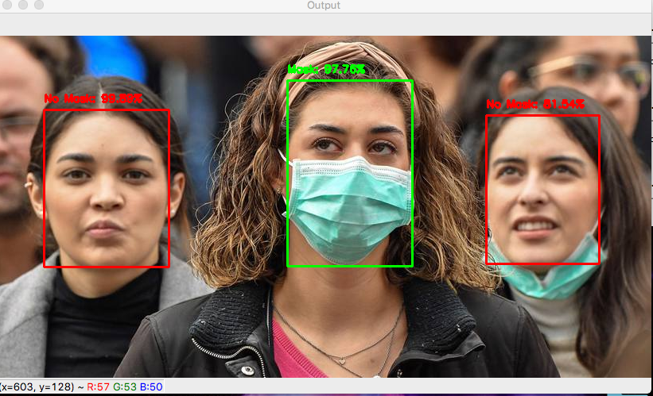 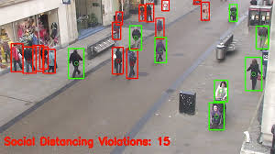

**Output for Drowsiness Detection:**

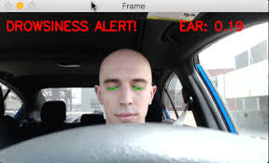

**Output for Age and Gender:**

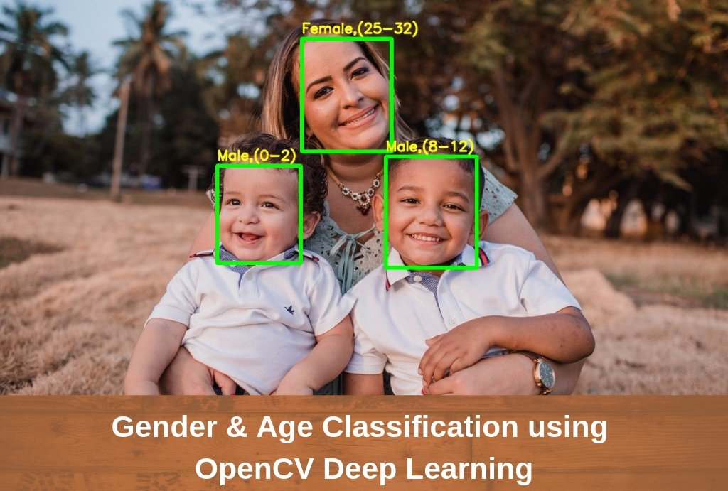

Predict the output of your Project.

**References:**

[1] M. ASJID TANVEER1 , M. JAWAD KHAN1 , M. JAHANGIR QURESHI2 “Enhanced Drowsiness Detection Using Deep Learning: An NIRS Study”, Received August 5, 2019, accepted September 6, 2019, date of publication September 23, 2019, date of current version October 3, 2019

[2] Rajesh Kumar G A1 , Ravi Kant Kumar2 , Goutam Sanyal3” Facial Emotion Analysis using Deep Convolution Neural Network” International Conference on Signal Processing and Communication (ICSPC’17) – 28th & 29th July 2017.

[3] Bhargava Reddy, Ye-Hoon Kim, Sojung Yun, Chanwon Seo, Junik Jang” Real-time Driver Drowsiness Detection for Embedded System Using Model Compression of Deep Neural Networks” 2017 IEEE Conference on Computer Vision and Pattern Recognition Workshops.

[4] Amrutha C.V, C. Jyotsna, Amudha J.” Deep Learning Approach for Suspicious Activity Detection from Surveillance Video” Proceedings of the Second International Conference on Innovative Mechanisms for Industry Applications (ICIMIA 2020) IEEE Xplore Part Number: CFP20K58-ART; ISBN: 978-1-7281-4167-1.

[5] Alavudeen Basha A, Parthasarathy P” Detection of Suspicious Human Activity based on CNN-DBNN Algorithm for Video Surveillance Applications” 2019 Innovations in Power and Advanced Computing Technology (i-PACT).

[6] Akriti Jaiswal, A. Krishnama Raju, Suman Deb” Facial Emotion Detection Using Deep Learning”, 2020 International Conference for Emerging Technology (INCET) Belgaum, India. Jun 5-7, 2020.

[7] Insha Rafique, Awais Hamid, Sheraz Naseer” Age and Gender Prediction using Deep Convolutional Neural Networks”, 2019 International Conference on Innovative Computing (ICIC).

[8] Li Fei, Wang Yajie, Qiu Hongkun, Wang Linlin” Gender Identification Using SVM Based on Human Face Images” 2014 International Conference on Virtual Reality and Visualization.